# Email Template Creation and Mgmt in Marketo

The template project will evolve as we decide what templates to prioritize, but below is a good start of how to create and manage templates in Marketo.

**Marketo Resources:**

* [Marketo](http://www.marketo.com)
* [Marketo Templates](http://templates.marketo.com/)
* [Marketo Community](https://nation.marketo.com/welcome)
  + [New to Marketo](http://learnadmin.marketo.com/ContentDetails.aspx?id=8BDC3CDE650F4602B599B11683B95E3B)
  + [Design Studio (3)](http://learnadmin.marketo.com/searchresults.aspx?q=template&ty=ML.BASE.DV.SearchAnyWords&at=T&ln=en-US&es=&CTGYLCL_CATEGORY_ID=9DA2E1E2096240C1A151498F389A49A8)

## Marketo: How to get to Templates screen and create new template

* **Note:** It’s recommended you create templates in a web authoring program like Dreamweaver before you create a new template in Marketo. Marketo has a preview and html option, but it’s not robust.
* Login to Marketo>Click Design Studio
* Navigate under ‘Emails’>Templates (open the + sign to reference list)
* Right click on ‘Templates’
* Select ‘New Email Template’
* Name: EMT_E_Banner_2blocks
  + (EmailTemplate_Event_banner_2blocks)
* A blank page with 2 tabs, ‘Previw’ and ‘HTML Source’ appears
* Click HTML Source to add the html template you’ve already worked on in a web authoring program.
* Toggle between Marketo and your web authoring program to copy and paste until ideal results
* **Note:** Always make sure all content blocks are editable for end user with this code around each content block:
  + Wrap all content in this div: div id’s: <div class="mktEditable" id="main-story" ></div>
  + Document naming convention for all div id’s: <div class="mktEditable" id="main-story" ></div>
* Once results are ideal, ask Web Assistant Director for review and approval
* Right click to approve template

This step is after you get a style guide created, you just want to make sure you catalog what templates are being used for what:

* Add a note to style guide as to what email types are using what template
* Ex: EMT_DA_Name for what template layout is_2016
  + Email types: Welcome, Get Ahead

## Marketo: How to grab content from current template for new template

* Click Template link under ‘summary’
* Directs you to the exact template in the Marketo Design Studio
* Click Edit draft
* Send naming convention (in Box) for Marketo asset creation

## Checklist for Template creation and mgmt

* **Apply branding and already available email templates resources:**
  + [Review IU Brand Guidelines>Dowloads>Web, Email, Social, etc.](http://brand.iu.edu/downloads/cas.php?path=web.shtml&casticket=ST-820712-2vsHfe3wovRnijHAfPjecasprd01)
  + [Review and use IU Web Style Guide](https://styleguide.iu.edu/index.html) for branding in template design
    - Use visual style, editorial style, pattern, etc.
    - Implement [IU global CSS & JS to template design](https://styleguide.iu.edu/developer-tools/css-js.html)
    - [Reference Framework starter from IU style guide](https://styleguide.iu.edu/developer-tools/github.html)
* **Familiarize yourself with our assets and naming conventions**
  + Ask Natalie where confirmed Science color palette is in Box
  + Setup meeting with Whitney to discuss event content layout/preferences from a student perspective
  + Review web for responsive email template designs for higher education
  + Get familiar with Marketo naming conventions: box file
  + EMT_User segment_
* **Create and use a Digital School of Science Style Guide**
* As you’re working on Templates, create Science web/email style guide
  + Save to Box as a word doc, apply above references to IU assets/IUPUI School of Science assets and [web style guide](https://styleguide.iu.edu/index.html)
    - Email template types
    - Fonts, palates, logos, image sizes for each type of template

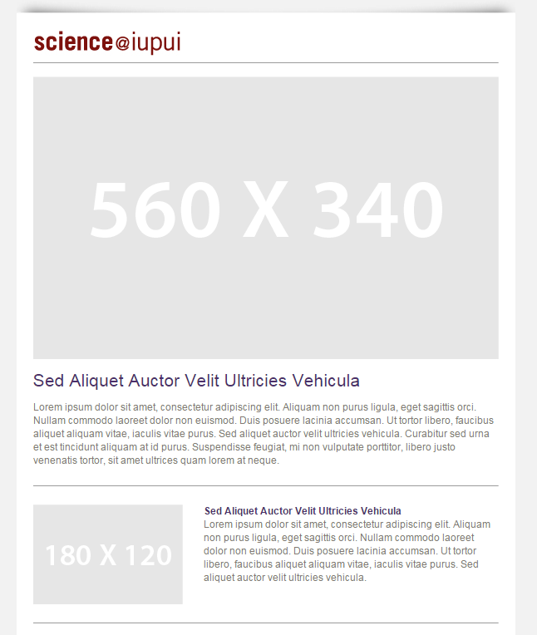

* Use same header and footer, making note that the links will change depending on the audience of the emails.
  + IU fulfilling the promise
    - Change the IU address to our Science address

SCHOOL OF SCIENCE RESOURCES

Administrative Office

402 N. Blackford, LD222

Indianapolis IN 46202

(317) 274-0625

science@iupui.edu

* + Same science logo
  + Social media tagline and icons
  + Footer links specific to each audience
* Make sure all content blocks are editable for end user with this code around each content block:
  + Wrap all content in this div: div id’s: <div class="mktEditable" id="main-story" ></div>
  + Document naming convention for all div id’s: <div class="mktEditable" id="main-story" ></div>
* Test all email templates and emails in xdesign
  + Test top browser
  + Screen resolution
  + Device type
    - Phones:
    - Tablet:
    - Desktop:

## Marketo Template List

* **Current email Templates**

Note: for some reason, these cannot be dragged and dropped into categories, we’ll have to figure this out as we go. Below is the list, in order as you see it in Marketo. However I’ve categorized them so you know what you’re looking at.

* **Goals:** 
  + Ideally, we’d like to go through these and delete what we don’t use. However, you cannot delete a template that is in-use somewhere else in Marketo, until you deactivate that asset.
  + We’d like a documented style guide for template naming conventions
  + We’d like to move to categorizing templates by email type and layout
    - Preferred Template organization:
      * EMT_autoresponders
      * EMT_ecard
      * EMT_events
      * EMT_surveys
        + In each folder will be templates named for how they are laid out

EMT_AR (autoresponder)_bannerimage_rightsidebar

EMT_ecard_videoandCTA

* Test Templates from [Marketo Templates](http://templates.marketo.com/), where you can download these templates into Marketo and recreate them with our content.
  + EM – Bizness – v1
  + EM – Floro – v1
  + EM – RoaylApp – v1
  + EM – Velada – v1
  + EM – Webinar – v1
  + EM – Zacor v1
* Email templates we’ve created, tested and are using or editing
  + Email Alert Template
  + Email Single Column Template
  + Email with Sidebar Template
  + EMT_Alumni-letter
  + EMT_Alumni-letter2
  + EMT_Autoresponsders_nophoto
  + EMT_Autoresponders_withphoto
  + EMT_Banner&Letter
  + EMT_Event Invite & Registration_Banner w/ 2 column
  + EMT_Event Invite_Small Banner – 2 column event
  + EMT_Event 2 column_highdetail
  + EMT_Event_BannerImage
  + EMT_EventBannerimage_body1datebody2
  + EMT_Evnet_DA_1CTA_1Banner
  + EMT_Event_GoldenGoggles_RegistrationReminder
  + EMT_Event_GoldenGogglesSurvey
  + EMT_Evnet_PicnicSurvey
  + EMT_Survey
  + EMT_ThisWeekInScience
  + EMT_URG_DA_EC_SocialMedia
  + EMT_URG_DA_EN_Monthlynews_v1
  + EMT_URG_DA_ EN_Monthlynews_v2
  + EMT_URG_DA_Invitation
  + EMT_URG_DA_SaveTheDate
  + EMT_URG_EC
  + EMT_WebinarConfirmation
  + EMT_WEbinarConfirmation_centeradagenda

# MARKETO TIPS

## Marketo Email Program: To add an email asset to an email program

* 1. Click Marketo circle at top left of screen
  2. Select ‘Marketing Activities’
  3. Open folders: Active Marketing Programs>Current Students>Email Programs CS>EM-MathFilmSeries2016
     + Right click the program’s folder “Local Assets”
     + Select ‘New Local Asset’
     + Select ‘Email’
     + Name: EM_CSPSAS_MathFilmSeries_3.16

(Email_CurrentStudentProspectiveStudentAdmittedStudent_MathFilmSeries_3.16)

* + - Description: This will be updated when email template/program approved
    - Template: Select the new template you created for this email program
    - Check box ‘Open in editor’
    - Click ‘Create’
    - A new tab will open with the new email
    - On left nav: Be sure to drag the email into the ‘Local Assets folder’
    - Edit From, Reply-to, Subject:
      * From: check to make sure it’s ‘IUPUI School of Science’
      * From email: science@iupui.edu
      * Reply-to: science@iupui.edu
      * Subject: To be decided on after email content created…
    - Make sure to hover over content to see the dotted box appear on all the content blocks you wrapped in the div id’s
      * div id’s: <div class="mktEditable" id="main-story" ></div>
    - Double click each element to open in web editor to make changes, etc.
    - Once email looks good, notify Erika to review it.

# Web Design Assistant Projects

Project 1: Update email event templates for the entire event communications stream

* Create 7 event communications stream templates with directions above
* Copy and paste Marketo link into a new tab so you can preview current event templates
* Ex: Golden Goggles email templates: Marketing Activities>Current Students>Events CS>Retention>LE.02.16 – Golden Goggles
* Email Templates to create
  1. Save The Date
     + Ex template name: (EMT_E_SD_banner_3blocks)

(Email template_Event_SaveDate_ banner(type of image)_3blocks (types of content))

* 1. Registration/Event invitation
     + Ex template name: (EMT_E_R_banner_3blocks)

(Email template_Event_registration_ banner(type of image)_3blocks (types of content))

* 1. **Registration/Event invitation reminder**

(Think about what makes a reminder email different – should there just be new images, same information? Maybe it should stay the same? Up to you.)

* + - Ex template name: (EMT_E_RR_banner_3blocks)

(Email template_Event_RegistrationReminder_ banner(type of image)_3blocks (types of content))

* 1. **Registration confirmation**
     + Ex template name: (EMT_E_RC_banner_3blocks)

(Email template_Event_RegistrationConfirmation_ banner(type of image)_3blocks (types of content))

* 1. **Users who registered – event reminder**
     + Ex template name: (EMT_E_REV_banner_3blocks)

(Email template_Event_RegisteredEventReminder_ banner(type of image)_3blocks (types of content))

* 1. **Follow up survey to registrants**
     + Ex template name: (EMT_E_S_banner_3blocks)

(Email template_Event_Survey_ banner(type of image)_3blocks (types of content))

* 1. **Basic autoresponder event email**

These go to our marketing team, notifying us when registrants register (You can use registrants information to populate a content summary, maybe an image, but that’s all you need for this template)

* + - Ex template name: (EMT_E_AR_banner_3blocks)

(Email template_Event_AutoResponder_ banner(type of image)_3blocks (types of content))